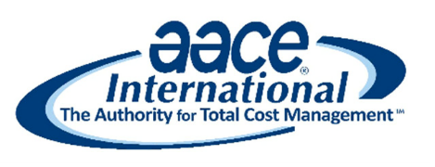

Contact: Ryan Mallory
Email: contact@aaceseattle.org
Website: www.aaceseattle.org/more/scholarships

FOR IMMEDIATE RELEASE
December 6th, 2020

2021 SCHOLARSHIP NOTICE – REVISION 0

Seattle, WA – The Seattle Section of AACE International (Association for the Advancement of Cost Engineering) the Authority for Total Cost Management, announces the opening of the 2021 Scholarship Award Program for graduate students.

Three (3) Scholarship Awards will be given at $1,000 each.
- A yearly membership to the AACEI Seattle Section will also be awarded with each scholarship
Applications due 11:59pm February 27, 2021.

Scholarship Eligibility:

- Residency – Applicants must be Washington State residents at the time of application. Proof of residency can be a Washington State driver’s license, or current voter registration, or utility bills for the past two billing periods.

- Eligible Academic Programs – Graduate academic programs that qualify for the Seattle Section AACE International Scholarship Program;

- Construction Management
- Engineering (Civil, Mechanical, Electrical, all others)
- Architecture
- Building Construction or Environment
- Other relevant programs (subject to Seattle Section AACE International Board approval)

3. Eligible Colleges – Washington State Colleges or Universities with Eligible Academic Programs.

4. Matriculation Status - Graduates who have declared a major in one of the above eligible programs, and subject to acceptance into that program for 2021-2022.

5. Academics - The graduate student must have been accepted to an eligible program and have attained at least a 2.5 GPA on a 4.0 scale with transcript.

6. Recommendation – The student must provide one letter of recommendation from their academic program or other non-related professional attesting to the applicant’s character.

7. Essay – 500-word or less essay that describes the applicant’s academic and future professional goals, along with any statement of financial need (see Application attached).

Criteria for Evaluation:

 GPA - 100 points
 Recommendation - 100 points
 Career Goals - 200 points
 Financial Need - 100 points

8. Payment of Award – The award shall be paid to the College or University as a credit towards the student’s tuition and/or related expenses.

Applications Due:
Post-marked no-later-than Saturday, February 27th, 2021.

Anticipated Date of Award:
April 2021 at the AACE Seattle Section meeting (if applicable).

Applications Should Be Addressed to:
AACE International – Seattle Section
c/o Ryan Mallory – Director of Education
5242 35th Ave SW
Seattle, WA 98126

* * * *

If you would like more information about AACE International, please see - http://web.aacei.org/about-aace/body-of-knowledge

For more information about the Seattle Section of AACE International, please see - http://aaceseattle.org/

Page | 2

