Admitted to Enrolled
Letter #7
Subject: WSU: A Great Place for Families
Dear Cheryl,
We understand that life becomes complicated when considering a graduate education in addition to caring for the wellbeing of your family.
Washington State University understand the issues graduate students face, from housing to health insurance to the quality of childcare and public schools. By providing a friendly, welcoming environment for graduate students and their families, WSU and the surrounding community show their commitment to making your graduate experience positive and successful.
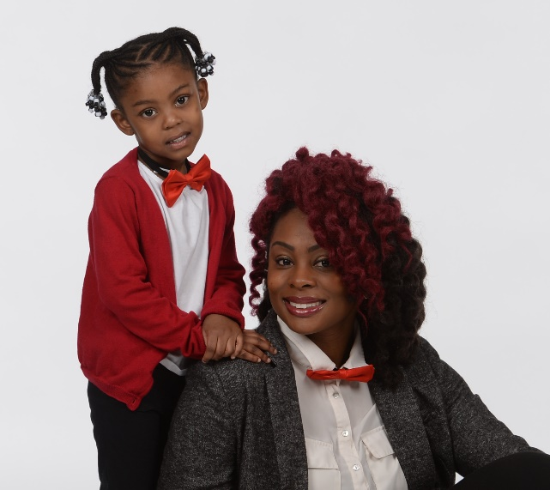
Ghynecee Temple and her daughter
When deciding where to attend graduate school, Ghynecee Temple of Tacoma, Washington, looked for a high-quality graduate program in an area that would be a good fit for her four-year-old daughter. Knowing her daughter would reside in a safe environment that values high-quality childcare and excellent public schools was paramount. When Ghynecee visited WSU Pullman, she knew it was a good fit.
“My daughter feels completely at home here,” Ghynecee said. “At the same time, as a single parent, I am determined to be a good role model for her, which includes pursuing an education and a meaningful career for myself.”
Ghynecee received an assistantship and fee waiver from her department to help defer costs, similar to approximately 44% of WSU graduate students. After accounting for students who receive scholarships, most graduate students receive some form of financial assistance. That’s a good financial plan for families embarking on new career paths.
The town of Pullman is ranked #4 among the 50 safest cities in Washington state. Pullman offers beauty, safety, and support in a college town atmosphere coupled with excellent childcare and some of the best public schools in the state. In addition, WSU Pullman has the lowest cost of living of all the PAC-12 schools - a bonus for families on a budget.
If you have other questions about accepting your admittance to WSU, contact the Graduate School or your department. gradschool@wsu.edu; 509-334-6424.
Sincerely,
The Graduate School

Visit your subscriptions page to unsubscribe from Graduate Admissions or manage similar email subscriptions from Washington State University.

