Admitted-to-Enrolled
Letter 6
Subject Line: What Can You Do at WSU?

Dear [ ],
If you’re still considering whether to accept your admittance to Washington State University, we’d like to what our current graduate students with families say about their WSU Pullman experience. If your program places you at one of our other campuses in Washington state, Spokane, Tri-Cities, Everett, or Vancouver, your admittance packet contains information about those locations. Learn more about our statewide system here.
WSU Pullman
The GPSA subsidizes evening care at the WSU Children’s Center. Evening childcare is available to all graduate/professional students, Monday through Thursday, 5:30-9:30, free of charge for the entire academic year after a one-time $50 registration fee.

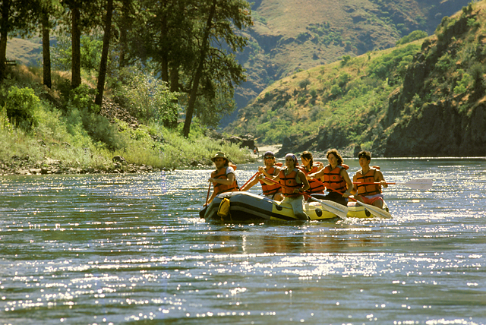

Graduate students with families say
- We enjoy taking our two kids, both too young for school, to the public library and to Bonkerz in Moscow [8 miles from Pullman]. We also really enjoy all the parks here in Pullman. Very kid friendly.
- My six-year-old son had a smooth transition into his new school, and he LOVED going to the WSU Children’s Center. I love that he went there, too, because it was such a great support.

Here are some of graduate students’ favorite family-friendly places
- Going to Silverwood Theme Park with the kids, hiking Kamiak Butte, walking the Chipman Trail, a paved trail that connects Pullman to neighboring town, Moscow, Idaho.
- Bike riding in downtown Pullman and shopping at the thrift shops!
- Bowling at Zeppoz, free movie night, football games.
- Regional Theatre of the Palouse, the Foundry and Etsi Bravo restaurants.
- Ferdinand’s Ice Cream Shoppe, Moscow Farmers Market and Food COOP, and Conner Museum.
- Dog park, summer movie night in the park, National Lentil Festival.
- Spokane, Farmers Markets, Robinson County Park, Moscow Mountain.
Pullman, Washington, may be unlike any other place you’ve lived. The town and surrounding area provide all types of outdoor activities, fine arts, and the unique culture of two land-grant universities only eight miles apart. The beautiful Pullman campus includes a high-tech recreation center and one of America’s finest golf courses.

In general, many students find that WSU and its community become like a second home. One student remarked, “The most amazing thing about WSU is probably the friendliness of fellow Coug. People here are gentle, friendly, and nice.”

We hope you decide to join the Cougar family at Washington State University! Feel free to explore the area more. Questions? Email gradschool@wsu.edu.
Sincerely,
Cindy Hollenbeck
Director of Communications
Graduate School

Visit your subscriptions page to unsubscribe from Graduate Admissions or manage similar email subscriptions from Washington State University.

