Admitted-to-enrolled
Letter #5

Subject: Why I Chose WSU

Dear [ ],
Hi! I'm Amber Morczek, a doctoral student at Washington State University. I'm writing to check in and see if you've accepted your admittance to the [ ] program yet, and if you have any questions. While you're thinking about whether or not to accept, let me tell you my story and why I chose to attend WSU.
You might say that I'm the poster child for achieving success despite much adversity and familial strife. I grew up in New York in a family plagued with poverty, trauma, addiction, and criminality. In an effort to improve my circumstances, I earned a bachelor's degree in psychology from SUNY Institute of Technology and a master's degree in criminal justice from SUNY College at Buffalo. In 2011, my cat, Plankton, and I left New York to make a new life at WSU Pullman so I could pursue a Ph.D. in criminal justice and criminality.
As part of my studies here at WSU, I became interested in institutional corrections and began to volunteer at prisons across Washington State. My life experiences have certainly prepared me to work in correctional settings, and I relish the work I do there. Moreover, I am often invited to speak with different groups on campus and beyond about my expertise--the connection between rape culture and gender-based violence. Consequently, since 2014, I've been invited to present more than 30 times locally and nationally to universities, state agencies, and community groups. A highlight of my career here at WSU as a doctoral student, though, was being invited to speak earlier this year at Syracuse University in New York. I had always eyed Syracuse from afar, never dreaming I would one day be invited to speak there. All these accomplishments were part and parcel to the support I received here at WSU.
My research at WSU has afforded me so many amazing opportunities. With the strong support of my faculty advisor, Dr. Faith Lutze, and the WSU community, I've been able to pursue my dreams. WSU has shown me what a supportive, opportunity-laden community feels like.
So if you're wondering whether or not WSU is your best choice for graduate school, I want you to know that this university is like a family, and if you embrace all the opportunities here, you can achieve anything you set your mind to.
I wish you the best of luck in your decisions about graduate school. If you have questions, don't hesitate to contact us! Gradschool@wsu.edu; 509-335-6424; gradschool.wsu.edu.
Sincerely,
Amber Morczek, Ph.D. Candidate
and Plankton
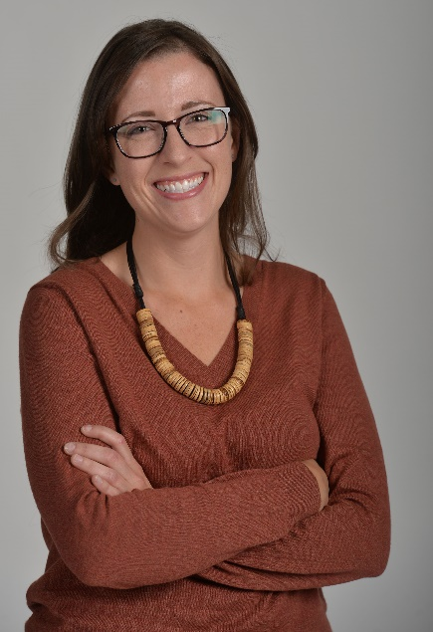

Visit your subscriptions page to unsubscribe from Graduate Admissions or manage similar email subscriptions from Washington State University.

