Admitted-to-Enrolled
Letter #3

Subject: Why WSU?

Dear ,
Congratulations again for being admitted to the [ ] program at Washington State University! My name is Amir Gilmore of Albany, New York, and I'm a doctoral student in Cultural Studies and Social Thought in Education at WSU. I chose Washington State University because of my faculty mentor, Dr. Paula Groves Price, and the wide-open spaces here for my dog, Jet.
When I arrived at WSU Pullman, I was surprised to find such a supportive, diverse, and friendly community. As a matter of fact, WSU attracts graduate students from more than 90 different countries worldwide! Pullman is located on the eastern edge of the state in a unique area known as the Palouse. The quiet residential campus offers a wide variety of recreational, cultural, and professional events, including the Professional Development Initiative to help graduate students grow leadership skills to enter their careers well-prepared.
WSU is also a statewide university with campuses in Vancouver, Tri-Cities, Spokane, and Everett, as well as research and extension centers throughout the state. Graduate students who choose programs at any of our campuses will find that each has the same school pride and cultural inclusiveness, with unique characteristics like world-class wine research in Tri-Cities and top healthcare research and training facilities in Spokane, where students receive hands-on training in the health sciences.
If you're committed to health and fitness, Pullman and the surrounding communities offer multiple resources for living a healthy lifestyle. The area is known for farmer's markets, a friendly food co-op, green bike program, a fabulous Student Recreation Center, and endless opportunities for hiking, biking, rafting, and skiing. WSU's Outdoor Recreation Program offers trips, clinics, and equipment rental (like a snowboard for $20/day, or a canoe for $24/day). At the end of your active day, you can relax at any of the eclectic local restaurants and enjoy dishes cooked with locally grown produce--or just hang out with friends at one of the many warm and cozy coffee shops.
If you're coming to WSU with a family, you'll be pleased to find quality schools and childcare here, plus enjoy the fact that WSU Pullman is a safe community. One graduate student with a family said, "My 6-year-old son transitioned well into his new school and he loved going to the WSU Children's Center. I loved that he went there, too, because it was such a great support." You can read more about family resources, including family housing and insurance, on our website.
Living in a small and supportive community as a graduate student has tremendous benefits, but living in a community that offers so many cultural, sport, and professional development opportunities-without all the traffic of a large city--is amazing.
Please join our graduate school community on Facebook and Twitter, and we hope to see you soon!
Sincerely,
Amir Gilmore, doctoral student
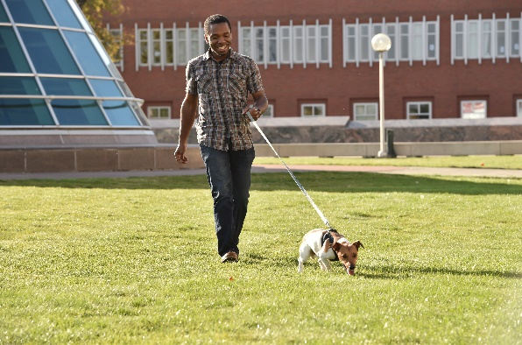

Visit your subscriptions page to unsubscribe from Graduate Admissions or manage similar email subscriptions from Washington State University.

