Troubleshooting issues with the Graduate School Sponsored Support Memo

The following is a list of instructions and things to try if the support memo is giving you some trouble. If what you are looking for isn’t in this file, please do not hesitate to contact Eric Powell via phone at x7687 or via email at eric.powell@wsu.edu – If you contact by email, please send as much detail as you can, including pictures if possible.

Trusting the form
We have instructions on the Graduate School website that explain how to setup and trust the form. But to know if you having trust issues is if you see the following at the top of the form: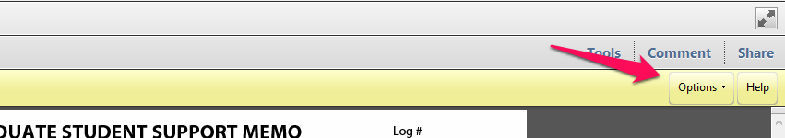
If you have the yellow bar above, you can click on the “Option” button and select “Trust this form one time only.”
As stated above, we have instructions on how to setup a “Trusted Location” on your computer where you can save the PDF to and it will not show that yellow bar. We have instructions for Windows XP, Windows 7, & Windows 8.

Support Memo not loading/working in a browser
Most current browsers come with a built-in PDF viewer. This built-in PDF view will interfere with the usage of the form, as they are not designed to load such forms. On the Graduate School website, we have instructions on how to deal with this issue in several different browsers. Click Here to view those instructions.

Support Memo saved and sent to another to sign, signature boxes not showing when opening the memo
If you are opening a memo that has been filled out previously to sign, and you cannot see the signature button (see example image below), please follow these steps.
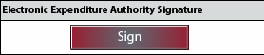

- Open and login to the support memo
- Once open, you should see the 3 buttons along the left side that indicate when section is being filled out (see example below)
- As shown below, click the selected radio button again. This will reactivate the section, won’t remove any data, and will give you access to the signature button again.
