How to track the location of a Support Memo

With the release of the new memo, you will be able to login to myGradSchool and check on the location of your submitted memos. Below are instructions on how to get to and see your memos.

1.) Go to mygradschool.wsu.edu, you will see the following: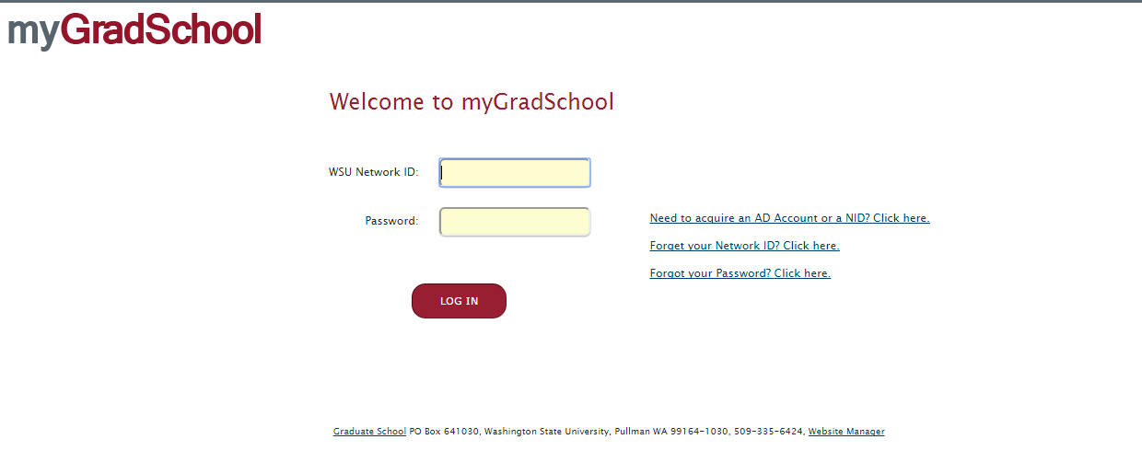
Login using your NetID and Password.
2.) Once logged in, you will see a row of tabs across the top. Click on “Fellowships”
Note: If it does not take you to the “Tracking” tab right away, you will need to click on the “Tracking” sub tab that will be listed below the main set of tabs.
3.) Once on the “Tracking” tab, you will see the following: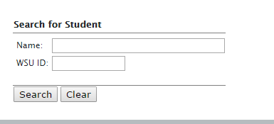
Enter in the information you want to search by and click search.

4.) The results page will come up showing the following:
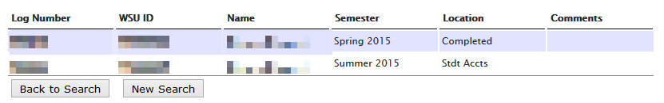
With the example WSU ID Number I used, you can see this student has two support memos, one for Spring 2015, which has gone through the entire process and is completed. And one for Summer 2015 that is still in Student Accounts.
By using this tracking page, you can see at any time, where the support memo is for a student and know who to contact about the memo if there is an issue.

If there are any problems with the tracking, you can’t see the “Fellowships” or “Tracking” tab, please do not hesitate to contact Eric Powell via phone at x7687 or via email at eric.powell@wsu.edu.

