How to Add a Trusted Folder Path to Adobe Acrobat
Windows 8/8.1
- Create the Folder
- Open Windows Explorer
  - Click the “Start” or “Windows” button and then type “file explorer”. Click on “File Explorer” in the results to open.
- Select the drive you want to create the folder in (Local Disk (C: ))
  - Click the arrow next to “This PC” then single left click on the item that has C: in its name (it may say Local Disk)
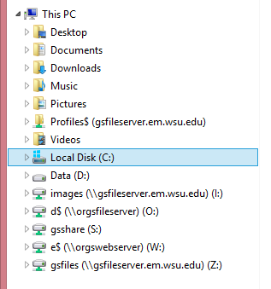
- Click “Create New Folder” – You may need to click the “Home” tab at the top first.
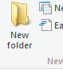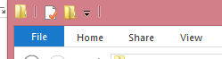
- Name the folder “SPS Memo” and press the enter key on your keyboard
- Add the folder to Privileged Locations in Adobe Acrobat
- Open Acrobat
- Click “Edit” and then “Preferences”
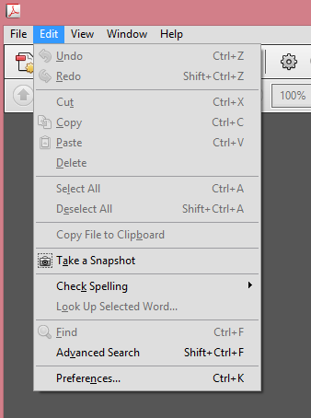
- Select “Security (Enhanced)”
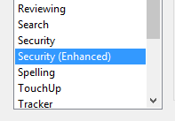
- Under “Privileged Locations” Click the “Add Folder Path” button
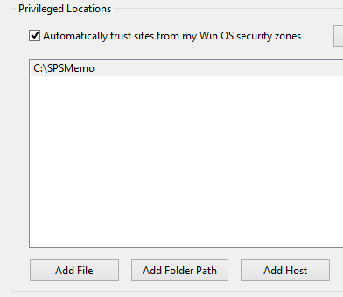
- Navigate to the SPS Memo folder you created
  - Click on “This PC”
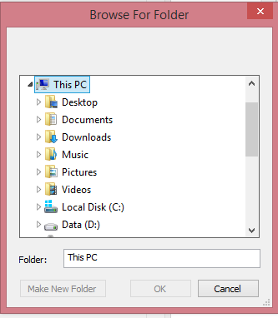
  - Click on “Local Disk (C: )”
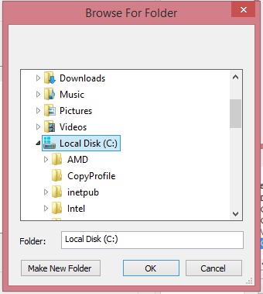
- Click to select the folder
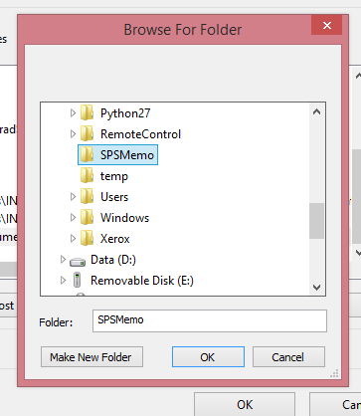
- Click OK
- Make sure the folder shows in the list
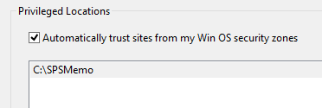
- Click OK again
YOU MUST SAVE THE SPS MEMO PDF FORM TO THIS FOLDER AND ONLY OPEN THE FORM FROM HERE.

